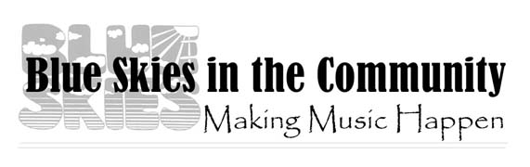EVENT REPORT
Please complete this report for Blue Skies in the Community, which provided funding for your event. This is an electronically expandable form in Word Format.

Sponsoring Organization:

Date and Duration of Approved Event:

Performers:

Numbers in Attendance: Children
Adults

Location of Event:

Evaluation of Event:

Impact of the BSIC grant on the Event:

If your event generated revenue, we would like to know how our grant fit into your final financial picture.

We use this information to keep track of BSIC sponsored opportunities and to promote and brag. Thank you!

Please return this form to Shannon Curry: <a href="mailto:beekslane@gmail.com">beekslane@gmail.com</a>

